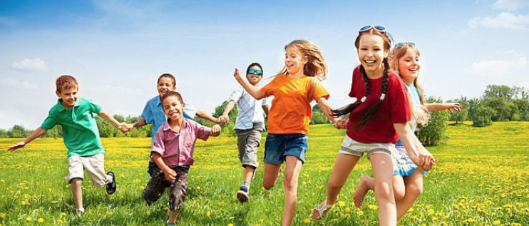
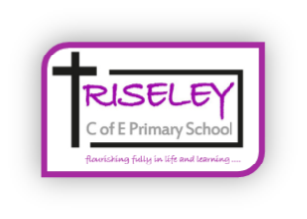

Children can identify and articulate the morals and messages within bible stories
Children understand the risks associated with drugs, alcohol and unhealthy food
Children learn to take and deal with risk
Children are resilient in the face of challenge
The Flourishing Child
Children are supportive of each other and look to help others
Children recognise how worship provides meaningful opportunities to contribute to their spiritual development
Children are inspired by Collective Worship
Children are reflective about their own performances
Children seek forgiveness and reconciliation after conflict
Children have a deep sense of responsibility for their learning
Children attend school regularly (above 97%)
Learning behaviour is excellent
Children are independent learners
Children value their education and recognise its importance
Children respect their own and others property
Children demonstrate a love for learning
Children understand how their bodies will change as they grow older
Children know how to keep themselves and others safe in and out of school
Children strive for their best and set high expectations
Children are happy in school and at home
Children understand the importance of physical activity
Children exercise regularly
Physical
Children appreciate the role that religion plays in other people’s lives
Children have high aspirations for themselves
Children take an active role in their own learning
Children can recall important facts from throughout their learning
Children demonstrate a healthy curiosity
Academic
Children make at least expected progress in all subject areas and in some accelerated progress
Children understand the importance of prayer and reflection
Children feel that they can express their ideas free from a fear of failure
Children can develop and maintain healthy relationships and friendships
Children work well with others to solve problems
Children can resolve conflicts and know how to deal with the negative emotions associated with them
Pupils respect and accept other people’s opinions
Children can discuss why we worship God/Jesus
Children appreciate other religion’s traditions and cultures
Children recognise and respect diversity and ways of living that may be different to their own
Children are polite and well-mannered
Children can accept and embrace failure as part of the learning journey
Spiritual
Social
Cultural
Moral

