

Riseley Church of England Primary School

Admissions Policy 2027-2028

Author/Responsible Officer | Leigh Pointon (Executive Headteacher)
Board to be ratified | Full Governing Body
Approved by | Loreen Shelford
Date of ratification | 17th November 2025
Date of next review | September 2026

Admissions Policy for Year of Entry 2027

Introduction
Riseley Church of England Primary School is a Voluntary Aided Church of England School within the Diocese of St Albans in the county of Bedfordshire. The Governing Body of the School is the Admission Authority. The Governors will admit up to the published admission number of 15 children to the Reception year group for the 2027-28 academic year. The Governing Body is required to abide by the maximum limits for infant classes (5, 6 and 7 year olds), i.e. 30 pupils per class.

The school provides for the admission of all successful applicants who have reached their 4th birthday by the beginning of September 2027. However please note the following:

- These arrangements do not apply to our nursery intake.
- Parents of children currently in our nursery must reapply for a place in reception.
- Attendance at our nursery does not guarantee a place in reception
- Parents offered a place may defer the date of their child’s admission until later in the year, or until the child reaches compulsory school age (or the start of the Easter term 2028, if earlier).
- Parents of a summer-born (1 April-31 August) child may choose not to send that child to school until the September following their fifth birthday and may either make an in year application for a place in year 1 or request that they are admitted out of their normal age group to Reception rather than Year 1. Please see page [7] for more information on how to make a request for admission out of year group. Parents are advised to make their request at the same time as making an on-time application for a place at the school in the child’s normal age group. If this recommended process is followed then the Governing Body will notify parents of the outcome of their request before any offer of a place is made. If the request is accepted then a new application for a Reception place must be made in the following year’s normal admission round, and there is no guarantee that a place will then be available. If the request is refused then parents must decide whether to accept any offer of a place in the child’s normal age group, or to refuse it and make an in year application for a place in year 1.
- Parents have the right to a part-time place for their child until the child reaches compulsory school age.
- The Local Authority (Bedford Borough) operates an agreed co-ordinated admissions scheme in line with government legislation. The LA will coordinate the process on behalf of the school according to 2 the scheme published each year. The Governing Body, as the admission authority, will allocate the available places in line with this policy. Please note that normal admissions round applications for a Reception place must be made to the child’s home local authority. Admissions information and the online application form for Bedford Borough residents can be found at [add link to Beds website admission oage here]

The closing date for admission application forms to be received by the home Local Authority is 15th January 2027.

All applications must be made on the applicant’s home LA common application form.

Please note that the information in this policy is correct for the year shown. Policies for future years may be different.

How places are offered

Pupils who have an Education Health and Care Plan which names the school will be admitted, even if the school is full, and before any oversubscription criteria are applied.

In the event of there being more applications than available places, the following oversubscription criteria will be applied, in order:

Category | Criteria
1 | All ‘looked after’ children or children who were previously ‘looked after’ but immediately after being ‘looked after’ became subject to an adoption, child arrangement or special guardianship order (see definitions)  Children who appear (to the admission authority of the school) to have been in state care outside of England and ceased to be in state care as a result of being adopted (see definitions)
2 | Children living in the catchment area with siblings at the school.
3 | Other pupils living in the catchment area.
4 | Children eligible for Early Years Pupil Premium, Pupil Premium or Service Premium Funding who are attending Riseley Preschool at the date of application.
5 | Other Siblings
6 | Children whose home address is outside the catchment area, but one or more of whose parents/guardians have, at the time of application shown commitment to the Church of England or another Christian Church by attending a service of public worship at least once a month for the year immediately prior to an application being made. Applicants who wish to be considered under this criterion must arrange for their priest or minister to complete and sign Bedford Borough’s religious declaration form at the time of application, in order to verify this attendance. In the event that during the period specified for attendance at worship the church has been closed for public worship and has not provided alternative premises for that worship, the requirements of these admissions arrangements in relation to attendance will only apply to the period when the church or alternative premises have been available for public worship
7 | Children of staff members
8 | Any other children

The governors cooperate with the fair access policies of the LA.
In the case of twins or multiple births, if one sibling has been allocated the last available place in class, the second twin or remaining multiple birth siblings will then be admitted as exceptions to the rule of maximum infant class size and remain so for the duration of their time in Reception/KS1.

Definitions
*Looked After
The Children’s Act 1989 defines a child who is ‘looked after’ as a child or young person who is (a) in the care of a local authority or (b) being provided with accommodation by a local authority in the exercise of its social services functions (as defined by section 22(1) of the Children Act 1989) at the time of an application being made to the school.

An ‘adoption order’ is an order under Section 46 of the Adoption and Children Act 2002. A ‘child arrangements order’ is an order setting out the arrangements to be made as to the person who whom the child is to live under Section 8 of the Children Act 1989, as amended by Section 12 of the Children and Families Act 2014. Section 14A of the Children Act 1989 defines a ‘special guardianship order’ as an order appointing one or more individuals to be a child’s special guardian (or special guardians).

*Looked After’ children from outside of England
A child is regarded as having been in state care in place outside of England if they were accommodated by a public authority, a religious organisation or any other provider of care whose sole or main purpose is to benefit society.

*Home address
A pupil’s home address will be regarded as the address of the parents or guardians with parental responsibility with whom the child normally lives. This will not usually include grandparents, aunts or uncles. Where a child spends time with parents at more than one address, the address used to allocate a school place will be one at which the pupil is ordinarily resident and where the child spends the majority of the school week (Mondays-Fridays) including nights. If a child lives at two addresses equally then parents/guardians should make one joint application naming one address. If there is any query on the home address this will be checked against official documentation e.g. council tax bill, a recent utility bill (gas, electricity or water), a rental agreement, child benefit statement or family tax credit information.

*Catchment area

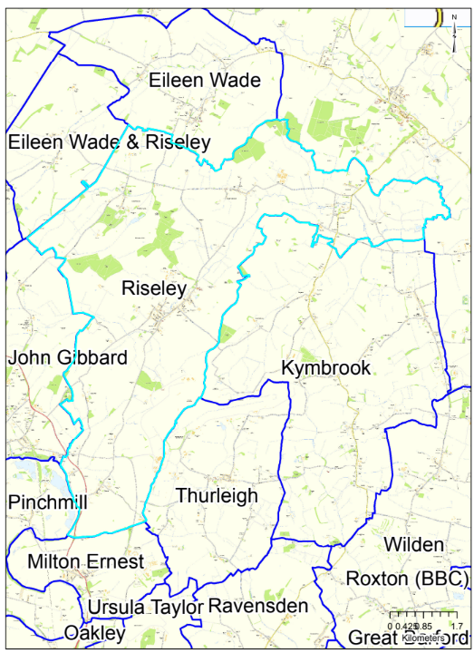

*Early Years Pupil Premium
The Early Years Pupil Premium (EYPP) is additional funding for early years settings to improve the education they provide for disadvantaged 3- and 4-year-olds.

*Pupil Premium
The Pupil Premium was introduced by the Coalition Government in April 2011 to provide the additional support for looked after children and those from low-income families. The extra funding is made available to schools to help them narrow the attainment gap that still exists between pupils from disadvantaged and more affluent backgrounds.

*Service Premium Funding
State schools, Academies and Free Schools in England, which have children of service personnel in reception to Year 11, can receive funding, which is designed to assist the school to provide mainly on-educational support (known as pastoral care) to these children.

*Christian Church
The governors define a ‘Christian’ church to be one which is a member of Churches Together in England or the Evangelical Alliance.

*Siblings
A sibling refers to a brother or sister, half brother or sister, adopted brother or sister, stepbrother or sister, foster brother or sister where foster care has been arranged by a local authority, or the child of the parent/carer’s partner, and in every case, the child should be living at the same address. The sibling must be in the school at the time of application and likely to remain in the school at the proposed date of admission.

*Children of staff members
The Governing Body will give priority under oversubscription criterion 7 to children of any staff member in either or both of the following circumstances:
- where the member of staff has been employed at the school for two or more years at the time at which the application for admission to the school is made, and/or
- the member of staff is recruited to fill a vacant post for which there is a demonstrable skill shortage

Notes
- If applying these criteria results in there being more children with an equal right to admission to the school than the number of available places, the tie break will be the distance the pupil lives from the school, measured in a straight line, using Bedford Borough’s computerised mapping system, with those living closer to the school receiving the higher priority. The distance will be measured from the address point of the pupil’s home to the front school gate. Each oversubscription criterion operates separately

- In the case of older children who apply to join the school after the 2027-28 academic year has started (“in-year applicants”), admission will be on the basis of places being available in the relevant class group. If there are more applicants for places than available, then the above oversubscription criteria will apply. Requests for in-year admission should be made on Bedford Borough’s In-Year application form and in accordance with Bedford Borough’s co-ordinated scheme for In-Year admissions. The form is available from the school or Local Authority and can also be downloaded from the Local Authority website. Criterion 6 applicants must also ask their priest or minister to complete and sign Bedford Borough’s religious declaration form.

- Pupils who have an Education Health and Care Plan naming the school will be admitted to the school, even if the school is full. Pupils identified for admission through the Fair Access Protocol will also be admitted even if the school is full. Parents of children eligible for consideration under the Fair Access Protocol may also make an in year application to the school.

- Parents who have not been allocated a place for their child have the right of appeal to an independent panel. The LA will explain the procedure to you if this situation arises.

- In the event of more applications than available places the governors will maintain a waiting list. These and late applications will go onto this list in a position determined by the criteria. The governors will maintain the list until the end of the Autumn Term (31st December). Parents are requested to inform the governors if they wish their child to remain on a waiting list after this date.

- Parents may make a request that their child is admitted outside of their normal age group. Such requests should be made by [e.g. letter addressed to the Governing Body c/o the school office]. The Governing Body will make decisions on the basis of the circumstances of each case and in the best interests of the child concerned. This will include taking account of the parents’ views; the views of the Headteacher of the school; information about the child’s academic, social and emotional development; where relevant, the child’s medical history and the view of a medical professional; whether the child has previously been educated out of year group; and whether the child might naturally have fallen into a lower age group if it were not for having been born prematurely. There is no right of appeal against the Governing Body’s decision not to admit outside the normal age group but reasons will be given for their decision.

- This policy has been ratified by the Governing Body and will be reviewed annually.

